Project Planning Phase
Project Planning Template (Product Backlog, Sprint Planning, Stories, Story points)

Date | 02 October 2026
Team ID | SWTID-2026-7899
Project Name | Auto Ticket Classification using Flow Designer
Maximum Marks | 5 Marks

Product Backlog, Sprint Schedule, and Estimation (4 Marks)
Use the below template to create product backlog and sprint schedule
Sprint | Functional Requirement (Epic) | User Story Number | User Story / Task | Story Points | Priority | Team Members
Sprint-1 | Incident Intake | USN-1 | As a service desk agent, I can capture an incident with a short description and detailed description so the issue is recorded for classification. | 2 | High | Project team
Sprint-1 | Incident Data Setup | USN-2 | As a ServiceNow administrator, I can configure the required incident fields and custom Incident Workflow table so classification data is stored consistently. | 3 | High | Project team
Sprint-1 | Category Configuration | USN-3 | As a service desk agent, I can select a category and a dependent subcategory so the incident classification stays consistent. | 2 | High | Project team
Sprint-2 | Keyword Classification | USN-4 | As a service desk agent, I want the flow to inspect incident text for configured keywords so common tickets can be classified automatically. | 5 | High | Project team
Sprint-2 | Classification Mapping | USN-5 | As a ServiceNow administrator, I can maintain keyword-to-category/subcategory mappings so classification can be adjusted as ticket patterns change. | 3 | High | Project team
Sprint-2 | Notifications | USN-6 | As a support team member, I receive an email notification when the configured workflow event occurs so I can follow up on the incident. | 2 | Medium | Project team
Sprint-3 | Testing & Validation | USN-7 | As a tester, I can submit sample incidents and verify the assigned category and subcategory so incorrect or unmatched classifications can be identified. | 3 | High | Project team
Sprint-3 | Deployment | USN-8 | As a ServiceNow administrator, I can package the workflow configuration in an update set so changes can be moved to the target instance. | 2 | Medium | Project team

Project Tracker, Velocity & Burndown Chart: (4 Marks)
Sprint | Total Story Points | Duration | Sprint Start Date | Sprint End Date (Planned) | Story Points Completed (as on Planned End Date) | Sprint Release Date (Actual)
Sprint-1 | 7 | 5 working days | To be scheduled | To be scheduled | Pending | Pending
Sprint-2 | 10 | 5 working days | To be scheduled | To be scheduled | Pending | Pending
Sprint-3 | 5 | 5 working days | To be scheduled | To be scheduled | Pending | Pending
Sprint-4 | 0 | 5 working days (buffer/review) | To be scheduled | To be scheduled | Pending | Pending

Velocity:
For this proposed plan, the first three sprints contain 22 estimated story points in total (7 + 10 + 5). Using a planning assumption of 5 working days per sprint, the average planned velocity across these sprints is 22 ÷ 3 = 7.3 story points per sprint, or approximately 1.5 story points per working day. This is an initial estimate; actual velocity must be recalculated from completed work after each sprint.


Burndown Chart:
The burndown chart tracks remaining work against sprint days. The chart below is an illustrative Sprint-2 example for 10 story points; actual daily completion values should be updated during execution.
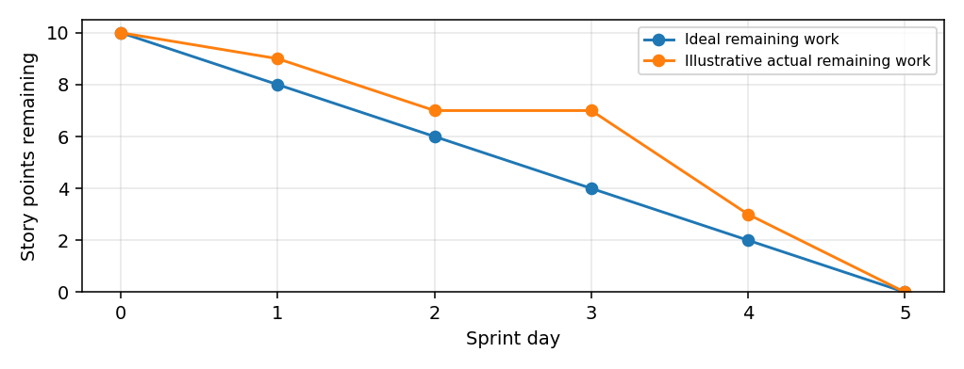
https://www.visual-paradigm.com/scrum/scrum-burndown-chart/
https://www.atlassian.com/agile/tutorials/burndown-charts

Reference:
https://www.atlassian.com/agile/project-management
https://www.atlassian.com/agile/tutorials/how-to-do-scrum-with-jira-software
https://www.atlassian.com/agile/tutorials/epics
https://www.atlassian.com/agile/tutorials/sprints
https://www.atlassian.com/agile/project-management/estimation
https://www.atlassian.com/agile/tutorials/burndown-charts

